ApexAuto Deliverable 2

Detailed Design and Rationale of Design Choices

Architecture Overview
ApexAuto Component Diagram
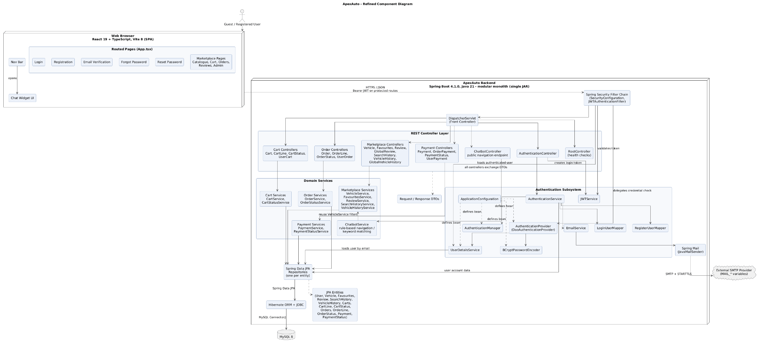
ApexAuto uses a three-tier client-server architecture. The React single-page application handles the user interface, the Spring Boot REST API handles business rules, and MySQL 8 stores persistent data. The back end is a layered modular monolith. Authentication, vehicles, favourites, reviews, carts, orders, payments, and the chatbot are organized as separate areas, but they run in one Spring Boot application and are deployed as one JAR.
The main request flow is React SPA to Spring Security to DispatcherServlet to REST controllers, services, repositories, Hibernate/JDBC, and MySQL. Spring Security checks protected requests. DispatcherServlet routes each request to the correct controller. Controllers handle HTTP input and output, services apply business rules, and repositories handle database access. Request and response DTOs keep the API contract separate from the JPA entities.

Design Choices and Patterns
The three-tier and layered structure separates presentation, business logic, and data access. This keeps controllers, services, repositories, DTOs, and entities focused on one role. The modular monolith keeps deployment simple and avoids the network and operational work of microservices while still organizing the code by business area.
Spring MVC provides the MVC structure, and DispatcherServlet acts as the Front Controller. Service classes such as VehicleService, CartService, OrderService, and PaymentService contain the business rules. Spring Data JPA repositories follow the DAO/Repository pattern and isolate persistence from the rest of the application.
DTOs define the data exchanged through the API, while RegisterUserMapper and LoginUserMapper handle authentication-related conversion. Spring dependency injection supplies services, repositories, security objects, and the BCrypt password encoder. JWTAuthenticationFilter follows the Intercepting Filter pattern by checking Bearer tokens before protected requests reach the controllers. These are common enterprise Java and JEE-style patterns implemented with Spring Boot.

Deployment Design and Cloud-Native Structure
ApexAuto Cloud Deployment Diagram
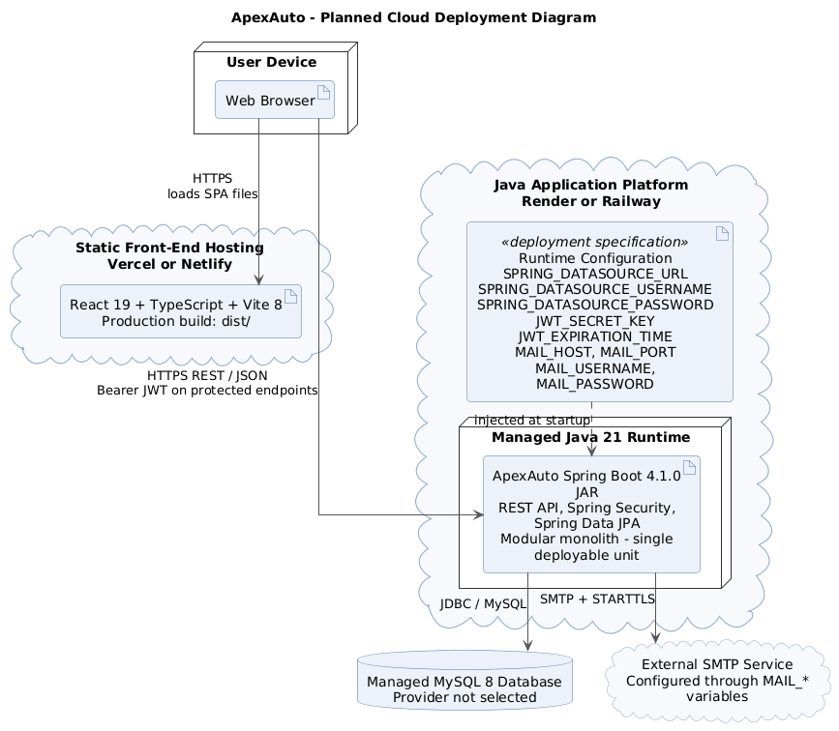
The React 19, TypeScript, and Vite 8 build will be hosted on Vercel or Netlify. The Spring Boot 4.1.0 application will run on Render or Railway using Java 21 and will be deployed as one JAR. A managed MySQL 8 database will store application data, and an external SMTP provider will send verification and password-reset emails.
Database, JWT, and SMTP settings will be supplied through environment variables. The system is cloud-native because the front end and back end can be deployed independently, authentication is stateless, and the database and email server are external services. Before deployment, the localhost API address and CORS settings must be updated for the production domains.

Quality Attributes
Security is supported by Spring Security, BCrypt password hashing, JWT authentication, email verification, password reset, token expiration, failed-login tracking, and account locking. Credentials and secrets are kept in environment variables. Production traffic will use HTTPS, and SMTP communication uses STARTTLS.
Performance is supported by static front-end hosting, JSON-based API calls, and database-side vehicle filtering through Spring Data JPA. Scalability is supported by stateless JWT authentication and separate deployment of the front end, back end, database, and SMTP service.
Maintainability and testability come from the separation between controllers, services, and repositories. Each layer can be changed or tested with fewer effects on the others. Reliability is supported by validation in the service layer and transactions for operations that update related records.

Activities Plan (Link for the document that contains full detail)

Product Log:
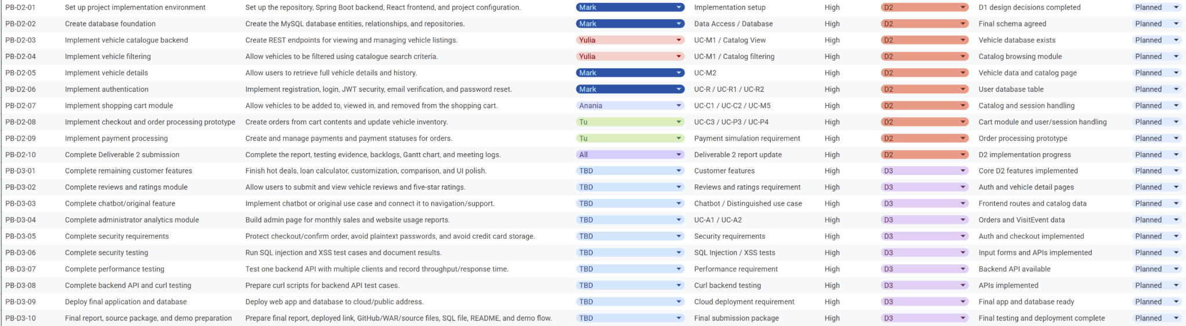

Sprint Log:
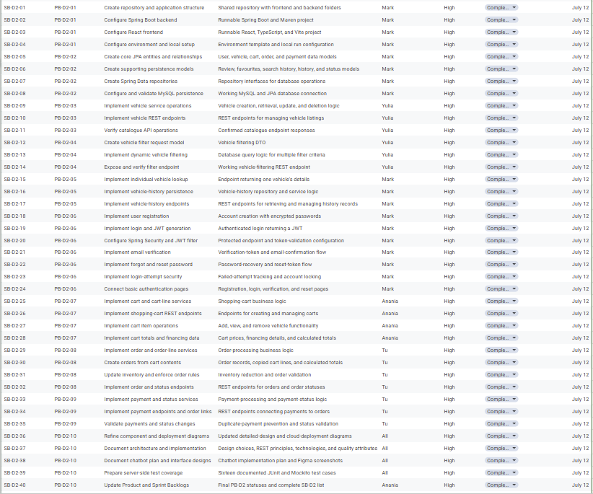

Gannt Chart:

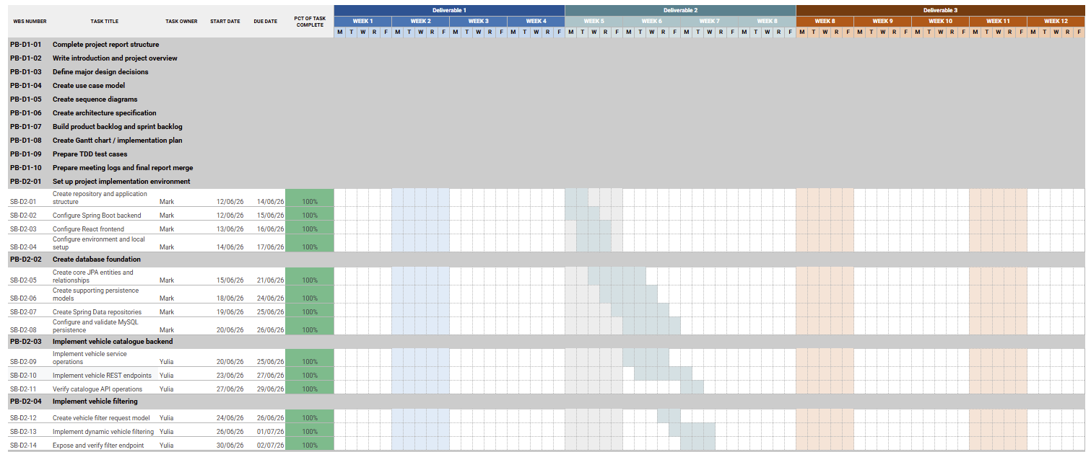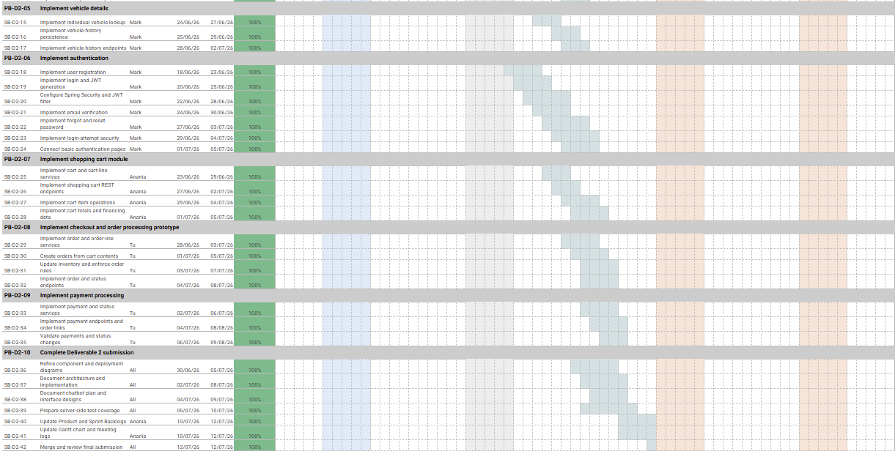

Meeting Logs:
Present Group Members | Meeting Date | Issues Discussed / Resolved
Anania Tsegaye, Mark Joseph Alconcel, Anh Tu Le, Yulia Obshansky | 2026-06-24 | Reviewed the Spring Boot and React project setup, MySQL database structure, and progress on the authentication and vehicle catalogue modules. Members confirmed the main entities, repositories, and REST endpoints required for the Deliverable 2 backend.
Anania Tsegaye, Mark Joseph Alconcel, Anh Tu Le, Yulia Obshansky | 2026-07-2 | Reviewed progress on the shopping cart, checkout, order, and payment modules. Members discussed how cart contents would be converted into orders, how inventory would be updated, and how payment and order statuses would be managed.
Anania Tsegaye, Mark Joseph Alconcel, Anh Tu Le, Yulia Obshansky | 2026-07-8 | Reviewed the refined component and deployment diagrams, Figma interface designs, server-side implementation description, and unit-test coverage. Members identified the remaining report sections and agreed on the work needed to complete the Activities Plan and testing evidence.
Anania Tsegaye, Mark Joseph Alconcel, Anh Tu Le, Yulia Obshansky | 2026-07-13 | Conducted the final Deliverable 2 review. The team finalized the Product Backlog, Sprint Backlog, Gantt chart, meeting logs, test coverage, and report sections. Members also discussed the Deliverable 3 plan, including frontend integration, chatbot implementation, analytics, cloud deployment, final testing, and demo preparation.

Server-Side Test Coverage
The selected 16 server-side test cases use JUnit 5 and Mockito. They focus on the service layer and use mocked repositories and supporting services. The tests cover authentication, account security, password recovery, cart pricing, loan calculations, order creation, inventory updates, and payment rules.
Test ID | Test Case | Test Class and File Name | Coverage
TC-01 | User registration | AuthenticationServiceTest  AuthenticationServiceTest.java | Saves a new user and sends an email verification message.
TC-02 | Login with a locked account | AuthenticationServiceTest  AuthenticationServiceTest.java | Rejects login when the account is already locked.
TC-03 | Failed login attempt | AuthenticationServiceTest  AuthenticationServiceTest.java | Increases and saves the failed-login count after bad credentials.
TC-04 | Account locked after three failed attempts | AuthenticationServiceTest  AuthenticationServiceTest.java | Locks the account after the third failed login.
TC-05 | Successful login resets failed attempts | AuthenticationServiceTest  AuthenticationServiceTest.java | Resets the failed-login count after successful authentication.
TC-06 | Valid email verification token | AuthenticationServiceTest  AuthenticationServiceTest.java | Verifies the user and clears valid token information.
TC-07 | Forgot-password request | AuthenticationServiceTest  AuthenticationServiceTest.java | Creates a reset token and expiry date and sends a reset email.
TC-08 | Successful password reset | AuthenticationServiceTest  AuthenticationServiceTest.java | Updates the encoded password, clears failed attempts, and unlocks the account.
TC-09 | Expired password-reset token | AuthenticationServiceTest  AuthenticationServiceTest.java | Rejects a password reset when the token has expired.
TC-10 | Add financed vehicle to cart | CartServiceTest  CartServiceTest.java | Stores financing details, monthly payment, interest, and total cost on the cart line.
TC-11 | Add cash purchase to cart | CartServiceTest  CartServiceTest.java | Stores the vehicle price and zero interest when financing is not used.
TC-12 | Zero-interest loan calculation | LoanServiceTest  LoanServiceTest.java | Calculates the expected payment and total cost at zero interest.
TC-13 | Invalid vehicle price for loan | LoanServiceTest  LoanServiceTest.java | Rejects a vehicle price of zero or less.
TC-14 | Change order after payment exists | OrderServiceTest  OrderServiceTest.java | Prevents adding a vehicle after a payment record exists for the order.
TC-15 | Create order from cart | OrderServiceTest  OrderServiceTest.java | Copies cart lines and financing data, calculates totals, and reduces stock.
TC-16 | Duplicate payment for an order | PaymentServiceTest  PaymentServiceTest.java | Rejects a second payment record for the same order.

Server-Side Implementation

Server-Side Structure
The ApexAuto back end is written in Java 21 using Spring Boot 4.1.0. Its main packages are controller, services, repository, entity, DTO, and configs. Protected requests first pass through JWTAuthenticationFilter, which reads the Bearer token, loads the user through UserDetailsService, validates the token, and places the authenticated user in the Spring Security context.
DispatcherServlet then sends the request to the correct REST controller. The controller reads path variables, query parameters, or DTOs and calls the appropriate service. The service applies business rules and uses Spring Data JPA repositories. Hibernate converts repository operations into SQL, MySQL stores the data, and the result is returned to the React client as JSON.

REST Principles
ApexAuto separates the client from the server: React handles the user interface, while Spring Boot handles business logic and database access. Protected requests are stateless because each request includes a JWT in the Authorization header and the server does not keep an HTTP login session.
The API is organized around resources such as vehicles, carts, orders, payments, reviews, favourites, search history, and vehicle history. GET retrieves data, POST creates resources, PUT or PATCH updates them, and DELETE removes them. Requests and responses use JSON, and DTOs define the API contract. Controllers return standard HTTP status codes for successful requests, invalid input, authentication failures, missing resources, and business conflicts.

Back-End Technologies
The back end uses Java 21, Spring Boot 4.1.0, Spring Web MVC, Spring Security, JJWT, BCrypt, Spring Data JPA, Hibernate, JDBC, MySQL Connector/J, MySQL 8, Spring Mail, JavaMailSender, Lombok, and Maven. Spring MVC provides REST endpoints, Spring Security and JJWT handle authentication, Spring Data JPA and Hibernate manage persistence, and Spring Mail sends account-related emails.

Planned Chatbot Implementation
The chatbot will provide navigation and vehicle-search support. A React chat widget in the navigation bar will send the user's message as JSON to a public ChatbotController endpoint. ChatbotController will call ChatbotService, which will use rule-based intent detection and keyword matching to identify values such as brand, model, year, colour, price range, availability, or a requested page.
For vehicle searches, ChatbotService will reuse the existing VehicleService filters. It will return a short response, a relevant link, or matching vehicles. The chatbot will run inside the existing Spring Boot application instead of a separate microservice. The first version will not require an external AI provider, machine-learning model, or vector database.

EECS 4413 Unit Testing File.pdf
ApexAuto_Design_Report.pdf

